###### A

Mini Project

On

**Learning from the once that got away detecting new form of phishing ATT**

(Submitted in partial fulfillment of the requirements for the award of Degree)

BACHELOR OF TECHNOLOGY

In

###### COMPUTER SCIENCE AND ENGINEERING

By

###### POKKILI SAMPATH KUMAR(197R1A05P1)

###### MUTHE AKHIL KUMAR (197R1A05N4)

###### RUDHRAMSH REDDY (197R1A05P3)

Under the Guidance of

**G. KALPANA DEVI**

(Associate Professor)



##### DEPARTMENT OF COMPUTER SCIENCE AND ENGINEERING

**CMR TECHNICAL CAMPUS UGC AUTONOMOUS**

(Accredited by NAAC, NBA, Permanently Affiliated to JNTUH, Approved by AICTE, New Delhi) Recognized Under Section 2(f) & 12(B) of the UGCAct.1956, Kandlakoya (V), Medchal Road, Hyderabad-501401.

**2019-2023**

**DEPARTMENT OF COMPUTER SCIENCE AND ENGINEERING**



#### CERTIFICATE

This is to certify that the project entitled **“Learning from the once that got away detecting new form of phishing ATT”** being submitted by **P.SAMPATH KUMAR(197R1A05P1), M.AKHILKUMAR(197R1A05N4) & R. RUDHRAMSH REDDY(197R1A05P3)** in partial fulfillment of the requirements for the award of the degree of B.Tech in Computer Science and Engineering to the Jawaharlal Nehru Technological University Hyderabad, is a record of bonafide work carried out by them under our guidance and supervision during the year 2022-23.

The results embodied in this thesis have not been submitted to any other University or Institute for the award of any degree or diploma.

**G. Kalpana Devi Dr. A. Raji Reddy**

(Associate Professor) DIRECTOR

INTERNAL GUIDE

**Dr. K. Srujan Raju EXTERNAL EXAMINER**

HOD

**Submitted for viva voice Examination held on**

##### ACKNOWLEDGEMENT

Apart from the efforts of us, the success of any project depends largely on the encouragement and guidelines of many others. We take this opportunity to express our gratitude to the people who have been instrumental in the successful completion of this project.

We take this opportunity to express my profound gratitude and deep regard to my guide **G. Kalpana Devi,** Associate Professor for her exemplary guidance, monitoring and constant encouragement throughout the project work. The blessing, help and guidance given by her shall carry us a long way in the journey of life on which we are about to embark.

We also take this opportunity to express a deep sense of gratitude to the Project Review Committee (PRC) **Dr. Punyaban Patel, Ms. Shilpa, Dr. M . Subha Mastan Rao & J. Narasimharao** for their cordial support, valuable information and guidance, which helped us in completing this task through various stages.

We are also thankful to **Dr. K. Srujan Raju,** Head, Department of Computer Science and Engineering for providing encouragement and support for completing this project successfully.

We are obliged to **Dr. A. Raji Reddy,** Director for being cooperative throughout the course of this project. We also express our sincere gratitude to Sri. **Ch. Gopal Reddy,** Chairman for providing excellent infrastructure and a nice atmosphere throughout the course of this project.

The guidance and support received from all the members of **CMR Technical Campus** who contributed to the completion of the project. We are grateful for their constant support and help.

Finally, we would like to take this opportunity to thank our family for their constant encouragement, without which this assignment would not be completed. We sincerely acknowledge and thank all those who gave support directly and indirectly in the completion of this project.

P. SAMPATH KUMAR (197R1A05P1)

**M. AKHIL KUMAR (197R1A05N4)**

**R. RUDHRAMSH REDDY (197R1A05P3)**

##### ABSTRACT

The criminals, who want to obtain sensitive data, first create unauthorized replicas of a real website and e-mail. The e-mail will be created using logos and slogans of a legitimate company. The nature of website creation is one of the reasons that the Internet has grown so rapidly as a communication medium. Phisher then send the "spoofed" e-mails to as many people as possible in an attempt to lure them into the scheme. When these e-mails are opened or when a link in the mail is clicked, the consumers are redirected to a spoofed website, appearing to be from the legitimate entity. We discuss the methods used for detection of phishing Web sites based on url importance properties.

Phishing attacks are a rapidly expanding threat in the cyber world, costing internet users billions of dollars each year. It is a criminal crime that involves the use of a variety of social engineering tactics to obtain sensitive information from users. Phishing techniques can be detected using a variety of types of communication, including email, instant chats, pop-up messages, and web pages. This study develops and creates a model that can predict whether a URL link is legitimate or phishing.

##### FIGURE NO FIGURE NAME PAGE NO

###### Figure 3.1 Project Architecture for Learning 7

###### From the once that got away detecting

###### New form of phishing ATT

###### Figure 3.2 Use Case Diagram for Learning 8

###### From the once that got away detecting

###### New form of phishing ATT

###### Figure 3.3 Class Diagram for Learning 9

###### From the once that got away detecting

###### New form of phishing ATT

###### 

###### Figure 3.4 Sequence diagram for Learning 10

###### From the once that got away detecting

###### New form of phishing ATT

###### Figure 3.5 Activity diagram for Learning 11

###### From the once that got away detecting

###### New form of phishing ATT

|  |  |  |
| --- | --- | --- |
| **SCREENSHOT NO.** | **SCREENSHOT NAME** | **PAGE NO**. |
| Screenshot 5.1 | Command Prompt | 27 |
| Screenshot 5.2 | Running the code and copying Generated URL | 28 |
| Screenshot 5.3 | Opening the URL Detection site | 29 |
| Screenshot 5.4 | Interface of PHISHING URL DETECTION | 30 |
| Screenshot 5.5  Screenshot 5.6 | Checking the unknown URL site    Result of the unknown URL  site | 31  37 |

ABSTRACT i

LIST OF FIGURES ii

LIST OF SCREENSHOTS iii

1. INTRODUCTION 1
   1. PROJECT SCOPE 1
   2. PROJECT PURPOSE 1
   3. PROJECT FEATURES 1
2. SYSTEM ANALYSIS 2
   1. PROBLEM DEFINITION 2
   2. EXISTING SYSTEM 2
      1. LIMITATIONS OF THE EXISTING SYSTEM 3
   3. PROPOSED SYSTEM 3
      1. ADVANTAGES OF PROPOSED SYSTEM 3
   4. FEASIBILITY STUDY 4
      1. ECONOMIC FEASIBILITY 4
      2. TECHNICAL FEASIBILITY 5
      3. SOCIAL FEASIBILITY 5
   5. HARDWARE & SOFTWARE REQUIREMENTS 6
      1. HARDWARE REQUIREMENTS 6
      2. SOFTWARE REQUIREMENTS 6
3. ARCHITECTURE 7
   1. PROJECT ARCHITECTURE 7
   2. DESCRIPTION 7
   3. USE CASE DIAGRAM 8
   4. CLASS DIAGRAM 9
   5. SEQUENCE DIAGRAM 10
   6. ACTIVITY DIAGRAM 11
4. IMPLEMENTATION 12
   1. SAMPLE CODE 12
5. RESULTS 27
6. TESTING 33
   1. INTRODUCTION TO TESTING 33
   2. TYPES OF TESTING 33
      1. UNIT TESTING 33
      2. INTEGRATION TESTING 34
      3. FUNCTIONAL TESTING 34
   3. TEST CASES 35
      1. CLASSIFICATION 35
7. CONCLUSION & FUTURE SCOPE 36
   1. PROJECT CONCLUSION 36
   2. FUTURE SCOPE 36
8. REFERENCES 37
   1. REFERENCES 37
   2. GITHUB LINK 37

# INTRODUCTION

#### 1.INTRODUCTION

##### PROJECT SCOPE

This project is titled “Learning from the once that got away detecting new form of phishing ATT”. explores data science and machine learning models that use datasets gotten from open-source platforms to analyze website links and distinguish between phishing and legitimate URL links. The model will be integrated into a web application, allowing a user to predict if a URL link is legitimate or phishing. This online application is compatible with a variety of browsers.

##### PROJECT PURPOSE

The main purpose of the project is to detect the fake or phishing websites who are trying to get access to the sensitive data or by creating the fake websites and trying to get access of the user personal credentials. We are using machine learning algorithms to safeguard the sensitive data and to detect the phishing websites who are trying to gain access on sensitive data.

##### PROJECT FEATURES

One of the challenges faced by our research was the unavailability of reliable training datasets. In fact, this challenge faces any researcher in the field. However, although plenty of articles about predicting phishing websites using data mining techniques have been disseminated these days, no reliable training dataset has been published publically, maybe because there is no agreement in literature on the definitive features that characterize phishing websites, hence it is difficult to shape a dataset that covers all possible features. In this article, we shed light on the important features that have proved to be sound and effective in predicting phishing websites. In addition, we proposed some new features, experimentally assign new rules to some well-known features and update some other features.

## SYSTEM ANALYSIS

##### SYSTEM ANALYSIS

**SYSTEM ANALYSIS**

The methodology of any research work refers to the research approach adopted by the researcher to tackle the stated problem. Since the efficiency and maintainability of any application are solely dependent on how designs are prepared. This chapter provides detailed descriptions of methods employed to proffer solutions to the stated objectives of the research work.

##### PROBLEM DEFINITION

Phishing is one of the techniques which are used by the intruders to get access to the user credentials or to gain access to the sensitive data. This type of accessing the is done by creating the replica of the websites which looks same as the original websites which we use on our daily basis but when a user click on the link he will see the website and think its original and try to provide his credentials.

##### EXISTING SYSTEM

The existing system of phishing detection techniques suffers low detection accuracy and high false alarm especially when different phishing approaches are introduced. Above and beyond, the most common technique used is the blacklist-based method which is inefficient in responding to emanating phishing attacks since registering a new domain has become easier, no comprehensive blacklist can ensure a perfect up-to-date database for phishing detection.

* + 1. DISADVANTAGES OF EXISTING SYSTEM

Following are the disadvantages of existing system:

* If Internet connection fails, this system won’t work.
* All websites related data will be stored in one place.

##### PROPOSED SYSTEM

The proposed phishing detection system utilizes machine learning models and deep neural networks. The system comprises two major parts, which are the machine learning models and a web application. These models consist of Decision Tree, Support Vector Machine, XG Booster, Multilayer Perceptions, Auto Encoder Neural Network, and Random Forest. These models are selected after different comparison-based performances of multiple machine learning algorithms. Each of these models is trained and tested on a website content-based feature, extracted from both phishing and legitimate dataset.

* + 1. ADVANTAGES OF THE PROPOSED SYSTEM
* Will be able to differentiate between phishing and legitimate
* It Will help reduce phishing data breaches for an organization
* It Will be helpful to individuals and organizations
* It is easy to use

##### FEASIBILITY STUDY

The feasibility of the project is analyzed in this phase and a business proposal is put forth with a very general plan for the project and some cost estimates. During system analysis the feasibility study of the proposed system is to be carried out. This is to ensure that the proposed system is not a burden to the company. Three key considerations involved in the feasibility analysis:

* Economic Feasibility
* Technical Feasibility
* Social Feasibility
  + 1. ECONOMIC FEASIBILITY

The developing system must be justified by cost and benefit. Criteria to ensure that effort is concentrated on a project, which will give best, return at the earliest. One of the factors, which affect the development of a new system, is the cost it would require.

The following are some of the important financial questions asked during preliminary investigation:

* + - * The costs conduct a full system investigation.
      * The cost of the hardware and software.
      * The benefits in the form of reduced costs or fewer costly errors.

Since the system is developed as part of project work, there is no manual cost to spend for the proposed system. Also all the resources are already available, it give an indication that the system is economically possible for development.

* + 1. TECHNICAL FEASIBILITY

This study is carried out to check the technical feasibility, that is, the technical requirements of the system. Any system developed must not have a high demand on the available technical resources. The developed system must have a modest requirement, as only minimal or null changes are required for implementing this system.

* + 1. SOCIAL FEASIBILITY

This includes the following questions:

* + - * Is there sufficient support for the users?
      * Will the proposed system cause harm?

The project would be beneficial because it satisfies the objectives when developed and installed. All behavioral aspects are considered carefully and conclude that the project is behaviorally feasible.

##### HARDWARE & SOFTWARE REQUIREMENTS

* + 1. HARDWARE REQUIREMENTS:

The following is the hardware requirements of the system for the proposed system

* + - * + Processor : Any Processor above 500 MHz
        + RAM : 8 GB
        + Hard disk : 1TB
        + Input device : Standard keyboard and mouse

##### 2.5.2 SOFTWARE REQUIREMENTS:

The following is the software requirements of the system for the proposed system

* OS : Windows 10
* Platform : Jupyter Notebook
* language : Python
* IDE/tool : Anaconda 3-5.0.3

## ARCHITECTURE

##### 3.ARCHITECTURE

##### PROJECT ARCHITECTURE

This project architecture shows the procedure followed for classification, starting from input to final prediction.

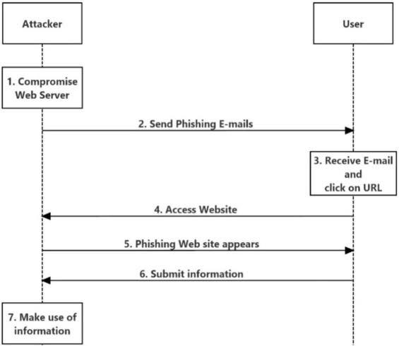

Figure 3.1: Project Architecture of Learning from the once that got away detecting new form of phishing ATT

* 1. DESCRIPTION

Phishing is a form of fraud in which the attacker tries to learn sensitive information such as login credentials or account information by sending as a reputable entity or person in email or other communication channels.

* 1. USE CASE DIAGRAM

In the use case diagram, we have basically one user.

A use case diagram at its simplest is a representation of a user’s interaction with the system and depicting the specifications of the use case.

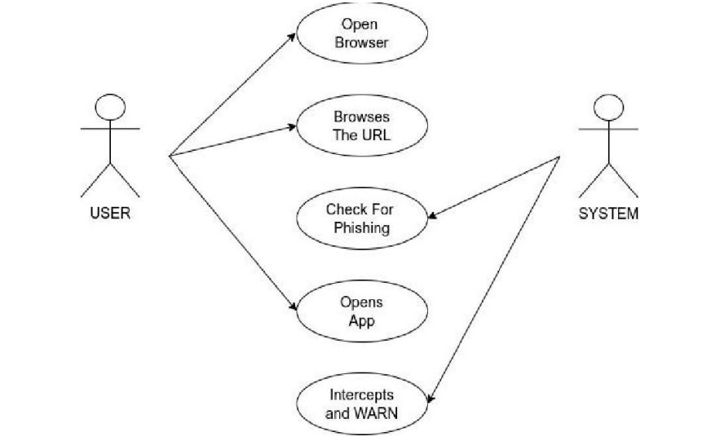

Figure 3.2: Use Case Diagram for Learning from the once that got away detecting new form of phishing ATT

##### CLASS DIAGRAM

Class diagram is a type of static structure diagram that describes the structure of a system by showing the system’s classes, their attributes, operations (or methods), and the relationships among objects.

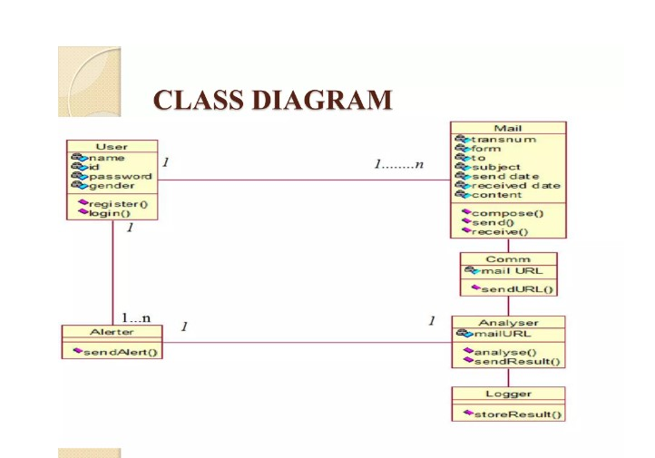

Figure 3.3: Class Diagram for Learning from the once that got away detecting new form of phishing ATT

##### SEQUENCE DIAGRAM

A sequence diagram shows object interactions arranged in time sequence. It depicts the objects involved in the scenario and the sequence of messages exchanged between the objects needed to carry out the functionality of the scenario. Sequence diagrams are typically associated with use case realizations in the logical view of the system under development.

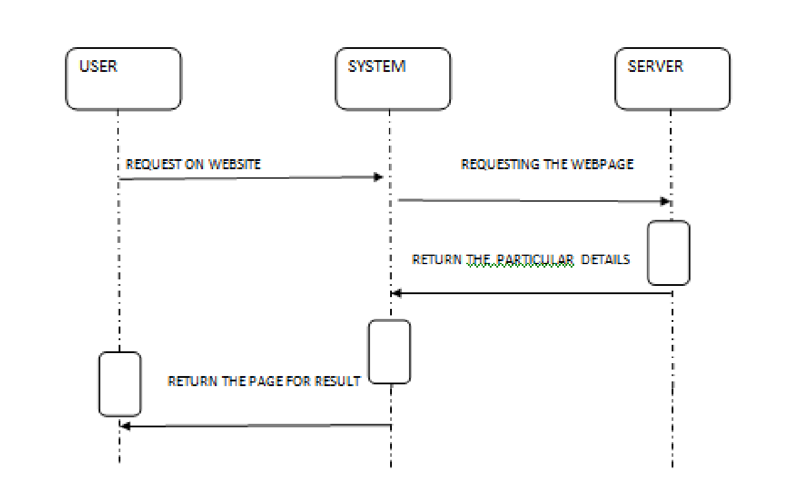

Figure 3.4: Sequence Diagram for Learning from the once that got away detecting new form of phishing ATT

* 1. ACTIVITY DIAGRAM

Activity diagrams are graphical representations of workflows of stepwise activities and actions with support for choice, iteration and concurrency. They can also include elements showing the flow of data between activities through one or more data stores.

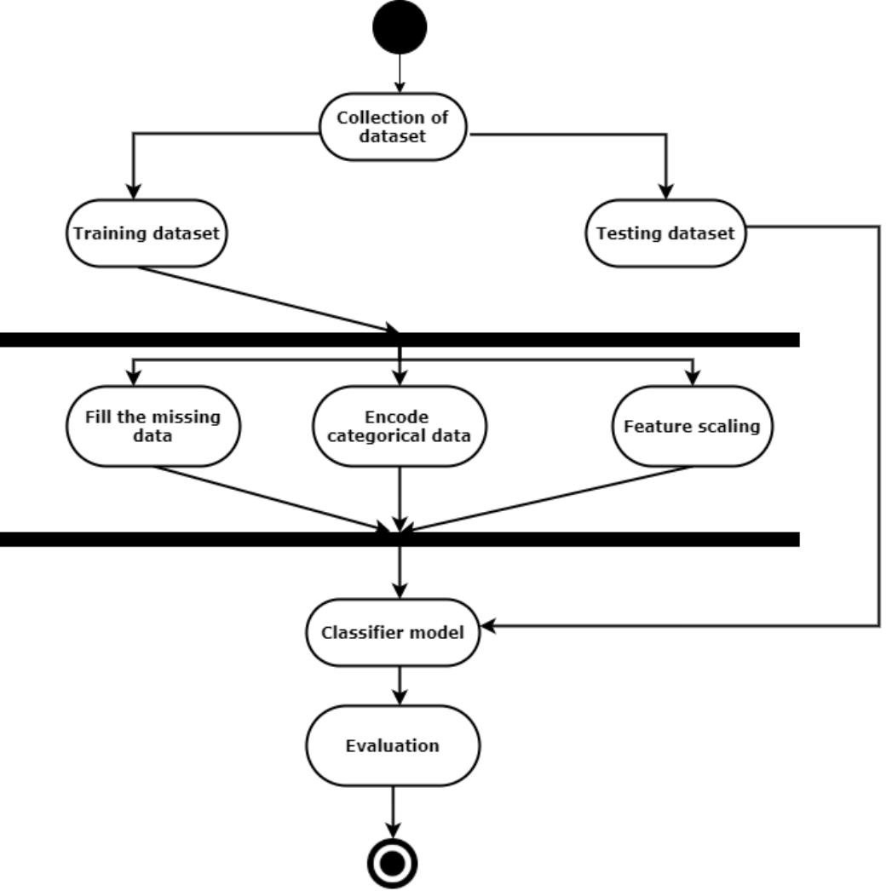

Figure 3.5: Activity Diagram for Learning from the once that got away detecting new form of phishing ATT

## 4.IMPLEMENTATION

##### 4.1 SAMPLE CODE

import ipaddress

import re

import urllib.request

from bs4 import BeautifulSoup

import socket

import requests

from googlesearch import search

import whois

from datetime import date, datetime

import time

from dateutil.parser import parse as date_parse

from urllib.parse import urlparse

class FeatureExtraction:

features = []

def __init__(self,url):

self.features = []

self.url = url

self.domain = ""

self.whois_response = ""

self.urlparse = ""

self.response = ""

self.soup = ""

try:

self.response = requests.get(url)

self.soup = BeautifulSoup(response.text, 'html.parser')

except:

pass

try:

self.urlparse = urlparse(url)

self.domain = self.urlparse.netloc

except:

pass

try:

self.whois_response = whois.whois(self.domain)

except:

pass

self.features.append(self.UsingIp())

self.features.append(self.longUrl())

self.features.append(self.shortUrl())

self.features.append(self.symbol())

self.features.append(self.redirecting())

self.features.append(self.prefixSuffix())

self.features.append(self.SubDomains())

self.features.append(self.Hppts())

self.features.append(self.DomainRegLen())

self.features.append(self.Favicon())

self.features.append(self.NonStdPort())

self.features.append(self.HTTPSDomainURL())

self.features.append(self.RequestURL())

self.features.append(self.AnchorURL())

self.features.append(self.LinksInScriptTags())

self.features.append(self.ServerFormHandler())

self.features.append(self.InfoEmail())

self.features.append(self.AbnormalURL())

self.features.append(self.WebsiteForwarding())

self.features.append(self.StatusBarCust())

self.features.append(self.DisableRightClick())

self.features.append(self.UsingPopupWindow())

self.features.append(self.IframeRedirection())

self.features.append(self.AgeofDomain())

self.features.append(self.DNSRecording())

self.features.append(self.WebsiteTraffic())

self.features.append(self.PageRank())

self.features.append(self.GoogleIndex())

self.features.append(self.LinksPointingToPage())

self.features.append(self.StatsReport())

# 1.UsingIp

def UsingIp(self):

try:

ipaddress.ip_address(self.url)

return -1

except:

return 1

# 2.longUrl

def longUrl(self):

if len(self.url) < 54:

return 1

if len(self.url) >= 54 and len(self.url) <= 75:

return 0

return -1

# 3.shortUrl

def shortUrl(self):

match = re.search('bit\.ly|goo\.gl|shorte\.st|go2l\.ink|x\.co|ow\.ly|t\.co|tinyurl|tr\.im|is\.gd|cli\.gs|'

'yfrog\.com|migre\.me|ff\.im|tiny\.cc|url4\.eu|twit\.ac|su\.pr|twurl\.nl|snipurl\.com|'

'short\.to|BudURL\.com|ping\.fm|post\.ly|Just\.as|bkite\.com|snipr\.com|fic\.kr|loopt\.us|'

'doiop\.com|short\.ie|kl\.am|wp\.me|rubyurl\.com|om\.ly|to\.ly|bit\.do|t\.co|lnkd\.in|'

'db\.tt|qr\.ae|adf\.ly|goo\.gl|bitly\.com|cur\.lv|tinyurl\.com|ow\.ly|bit\.ly|ity\.im|'

'q\.gs|is\.gd|po\.st|bc\.vc|twitthis\.com|u\.to|j\.mp|buzurl\.com|cutt\.us|u\.bb|yourls\.org|'

'x\.co|prettylinkpro\.com|scrnch\.me|filoops\.info|vzturl\.com|qr\.net|1url\.com|tweez\.me|v\.gd|tr\.im|link

\.zip\.net', self.url)

if match:

return -1

return 1

# 4.Symbol@

def symbol(self):

if re.findall("@",self.url):

return -1

return 1

# 5.Redirecting//

def redirecting(self):

if self.url.rfind('//')>6:

return -1

return 1

# 6.prefixSuffix

def prefixSuffix(self):

try:

match = re.findall('\-', self.domain)

if match:

return -1

return 1

except:

return -1

# 7.SubDomains

def SubDomains(self):

dot_count = len(re.findall("\.", self.url))

if dot_count == 1:

return 1

elif dot_count == 2:

return 0

return -1

# 8.HTTPS

def Hppts(self):

try:

https = self.urlparse.scheme

if 'https' in https:

return 1

return -1

except:

return 1

# 9.DomainRegLen

def DomainRegLen(self):

try:

expiration_date = self.whois_response.expiration_date

creation_date = self.whois_response.creation_date

try:

if(len(expiration_date)):

expiration_date = expiration_date[0]

except:

pass

try:

if(len(creation_date)):

creation_date = creation_date[0]

except:

pass

age = (expiration_date.year-creation_date.year)*12+ (expiration_date.month-creation_date.month)

if age >=12:

return 1

return -1

except:

return -1

# 10. Favicon

def Favicon(self):

try:

for head in self.soup.find_all('head'):

for head.link in self.soup.find_all('link', href=True):

dots = [x.start(0) for x in re.finditer('\.', head.link['href'])]

if self.url in head.link['href'] or len(dots) == 1 or domain in head.link['href']:

return 1

return -1

except:

return -1

# 11. NonStdPort

def NonStdPort(self):

try:

port = self.domain.split(":")

if len(port)>1:

return -1

return 1

except:

return -1

# 12. HTTPSDomainURL

def HTTPSDomainURL(self):

try:

if 'https' in self.domain:

return -1

return 1

except:

return -1

# 13. RequestURL

def RequestURL(self):

try:

for img in self.soup.find_all('img', src=True):

dots = [x.start(0) for x in re.finditer('\.', img['src'])]

if self.url in img['src'] or self.domain in img['src'] or len(dots) == 1:

success = success + 1

i = i+1

for audio in self.soup.find_all('audio', src=True):

dots = [x.start(0) for x in re.finditer('\.', audio['src'])]

if self.url in audio['src'] or self.domain in audio['src'] or len(dots) == 1:

success = success + 1

i = i+1

for embed in self.soup.find_all('embed', src=True):

dots = [x.start(0) for x in re.finditer('\.', embed['src'])]

if self.url in embed['src'] or self.domain in embed['src'] or len(dots) == 1:

success = success + 1

i = i+1

for iframe in self.soup.find_all('iframe', src=True):

dots = [x.start(0) for x in re.finditer('\.', iframe['src'])]

if self.url in iframe['src'] or self.domain in iframe['src'] or len(dots) == 1:

success = success + 1

i = i+1

try:

percentage = success/float(i) * 100

if percentage < 22.0:

return 1

elif((percentage >= 22.0) and (percentage < 61.0)):

return 0

else:

return -1

except:

return 0

except:

return -1

# 14. AnchorURL

def AnchorURL(self):

try:

i,unsafe = 0,0

for a in self.soup.find_all('a', href=True):

if "#" in a['href'] or "javascript" in a['href'].lower() or "mailto" in a['href'].lower() or not (url in a['href'] or self.domain in a['href']):

unsafe = unsafe + 1

i = i + 1

try:

percentage = unsafe / float(i) * 100

if percentage < 31.0:

return 1

elif ((percentage >= 31.0) and (percentage < 67.0)):

return 0

else:

return -1

except:

return -1

except:

return -1

# 15. LinksInScriptTags

def LinksInScriptTags(self):

try:

i,success = 0,0

for link in self.soup.find_all('link', href=True):

dots = [x.start(0) for x in re.finditer('\.', link['href'])]

if self.url in link['href'] or self.domain in link['href'] or len(dots) == 1:

success = success + 1

i = i+1

for script in self.soup.find_all('script', src=True):

dots = [x.start(0) for x in re.finditer('\.', script['src'])]

if self.url in script['src'] or self.domain in script['src'] or len(dots) == 1:

success = success + 1

i = i+1

try:

percentage = success / float(i) * 100

if percentage < 17.0:

return 1

elif((percentage >= 17.0) and (percentage < 81.0)):

return 0

else:

return -1

except:

return 0

except:

return -1

# 16. ServerFormHandler

def ServerFormHandler(self):

try:

if len(self.soup.find_all('form', action=True))==0:

return 1

else :

for form in self.soup.find_all('form', action=True):

if form['action'] == "" or form['action'] == "about:blank":

return -1

elif self.url not in form['action'] and self.domain not in form['action']:

return 0

else:

return 1

except:

return -1

# 17. InfoEmail

def InfoEmail(self):

try:

if re.findall(r"[mail\(\)|mailto:?]", self.soap):

return -1

else:

return 1

except:

return -1

# 18. AbnormalURL

def AbnormalURL(self):

try:

if self.response.text == self.whois_response:

return 1

else:

return -1

except:

return -1

# 19. WebsiteForwarding

def WebsiteForwarding(self):

try:

if len(self.response.history) <= 1:

return 1

elif len(self.response.history) <= 4:

return 0

else:

return -1

except:

return -1

# 20. StatusBarCust

def StatusBarCust(self):

try:

if re.findall("<script>.+onmouseover.+</script>", self.response.text):

return 1

else:

return -1

except:

return -1

# 21. DisableRightClick

def DisableRightClick(self):

try:

if re.findall(r"event.button ?== ?2", self.response.text):

return 1

else:

return -1

except:

return -1

# 22. UsingPopupWindow

def UsingPopupWindow(self):

try:

if re.findall(r"alert\(", self.response.text):

return 1

else:

return -1

except:

return -1

# 23. IframeRedirection

def IframeRedirection(self):

try:

if re.findall(r"[<iframe>|<frameBorder>]", self.response.text):

return 1

else:

return -1

except:

return -1

# 24. AgeofDomain

def AgeofDomain(self):

try:

creation_date = self.whois_response.creation_date

try:

if(len(creation_date)):

creation_date = creation_date[0]

except:

pass

today = date.today()

age = (today.year-creation_date.year)*12+(today.month-creation_date.month)

if age >=6:

return 1

return -1

except:

return -1

# 25. DNSRecording

def DNSRecording(self):

try:

creation_date = self.whois_response.creation_date

try:

if(len(creation_date)):

creation_date = creation_date[0]

except:

pass

today = date.today()

age = (today.year-creation_date.year)*12+(today.month-creation_date.month)

if age >=6:

return 1

return -1

except:

return -1

# 26. WebsiteTraffic

def WebsiteTraffic(self):

try:

rank = BeautifulSoup(urllib.request.urlopen("http://data.alexa.com/data?cli=10&dat=s&url=" + url).read(), "xml").find("REACH")['RANK']

if (int(rank) < 100000):

return 1

return 0

except :

return -1

# 27. PageRank

def PageRank(self):

try:

prank_checker_response =

requests.post("https://www.checkpagerank.net/index.php", {"name": self.domain})

global_rank = int(re.findall(r"Global Rank: ([0-9]+)", rank_checker_response.text)[0])

if global_rank > 0 and global_rank < 100000:

return 1

return -1

except:

return -1

# 28. GoogleIndex

def GoogleIndex(self):

try:

site = search(self.url, 5)

if site:

return 1

else:

return -1

except:

return 1

# 29. LinksPointingToPage

def LinksPointingToPage(self):

try:

number_of_links = len(re.findall(r"<a href=", self.response.text))

if number_of_links == 0:

return 1

elif number_of_links <= 2:

return 0

else:

return -1

except:

return -1

# 30. StatsReport

def StatsReport(self):

try:

url_match = re.search(

'at\.ua|usa\.cc|baltazarpresentes\.com\.br|pe\.hu|esy\.es|hol\.es|sweddy\.com|myjino\.ru|96\.lt|ow\.ly', url)

ip_address = socket.gethostbyname(self.domain)

ip_match = re.search('146\.112\.61\.108|213\.174\.157\.151|121\.50\.168\.88|192\.185\.217\.116|78\.46\.211\.158|181\.174\.165\.13|46\.242\.145\.103|121\.50\.168\.40|83\.125\.22\.219|46\.242\.145\.98|'

'107\.151\.148\.44|107\.151\.148\.107|64\.70\.19\.203|199\.184\.144\.27|107\.151\.148\.108|107\.151\.148\.109|119\.28\.52\.61|54\.83\.43\.69|52\.69\.166\.231|216\.58\.192\.225|'

'118\.184\.25\.86|67\.208\.74\.71|23\.253\.126\.58|104\.239\.157\.210|175\.126\.123\.219|141\.8\.224\.221|10\.10\.10\.10|43\.229\.108\.32|103\.232\.215\.140|69\.172\.201\.153|'

'216\.218\.185\.162|54\.225\.104\.146|103\.243\.24\.98|199\.59\.243\.120|31\.170\.160\.61|213\.19\.128\.77|62\.113\.226\.131|208\.100\.26\.234|195\.16\.127\.102|195\.16\.127\.157|'

'34\.196\.13\.28|103\.224\.212\.222|172\.217\.4\.225|54\.72\.9\.51|192\.64\.147\.141|198\.200\.56\.183|23\.253\.164\.103|52\.48\.191\.26|52\.214\.197\.72|87\.98\.255\.18|209\.99\.17\.27|'

'216\.38\.62\.18|104\.130\.124\.96|47\.89\.58\.141|78\.46\.211\.158|54\.86\.225\.156|54\.82\.156\.19|37\.157\.192\.102|204\.11\.56\.48|110\.34\.231\.42', ip_address)

if url_match:

return -1

elif ip_match:

return -1

return 1

except:

return 1

def getFeaturesList(self):

return self.features

## 5.RESULTS

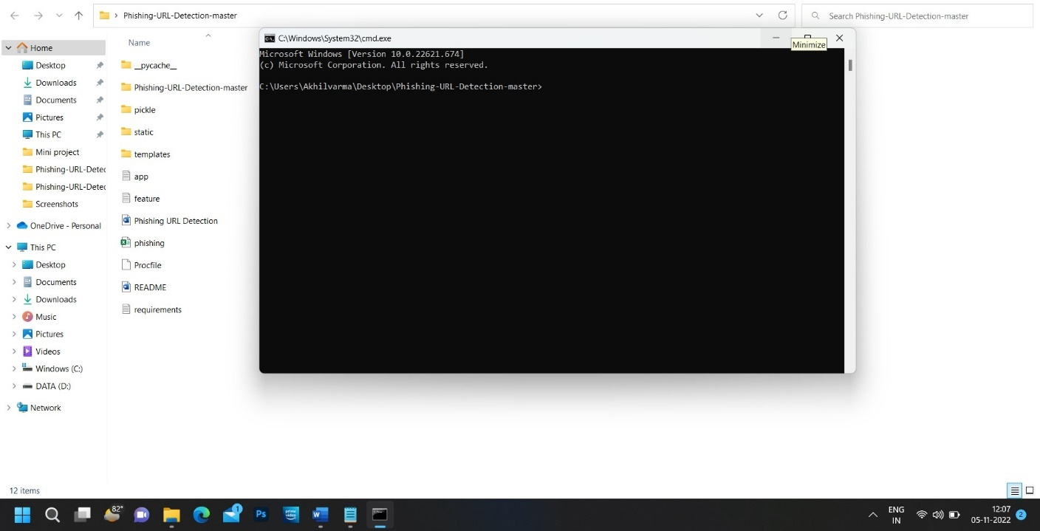

Screenshot 5.1: Command prompt

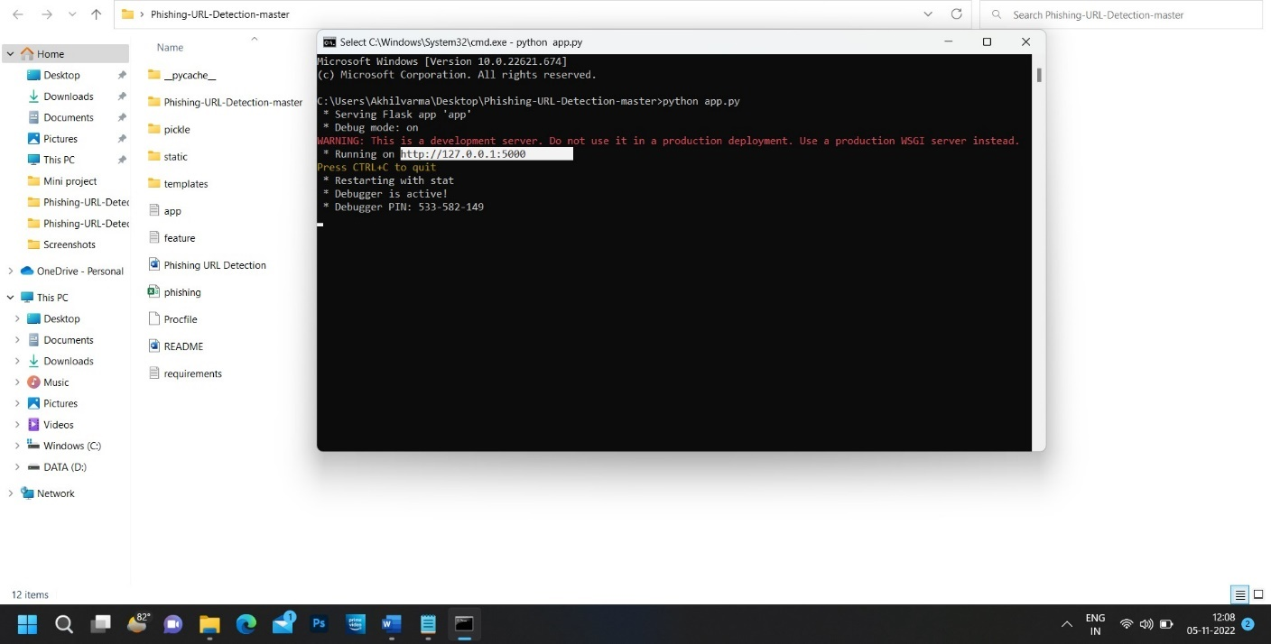

Screenshot 5.2: Running the code and copying the generated URL

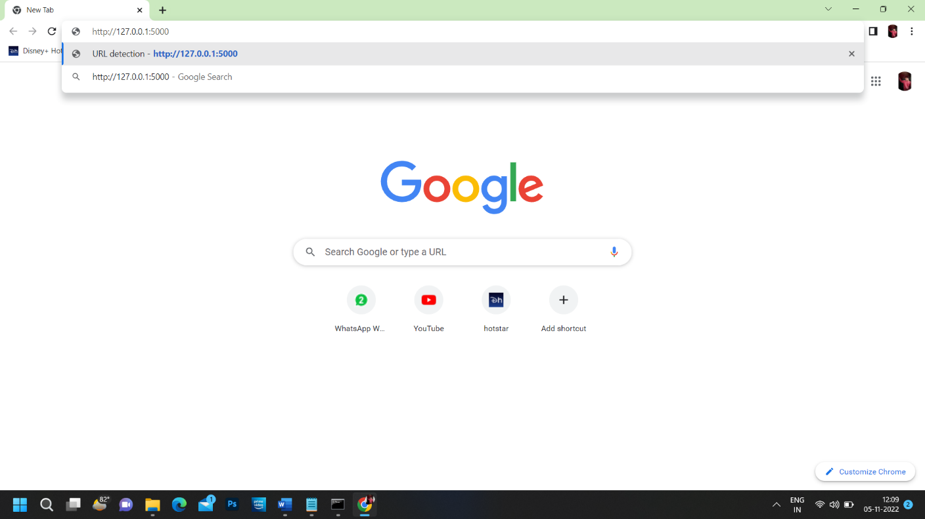

Screenshot 5.3: Opening the URL detection

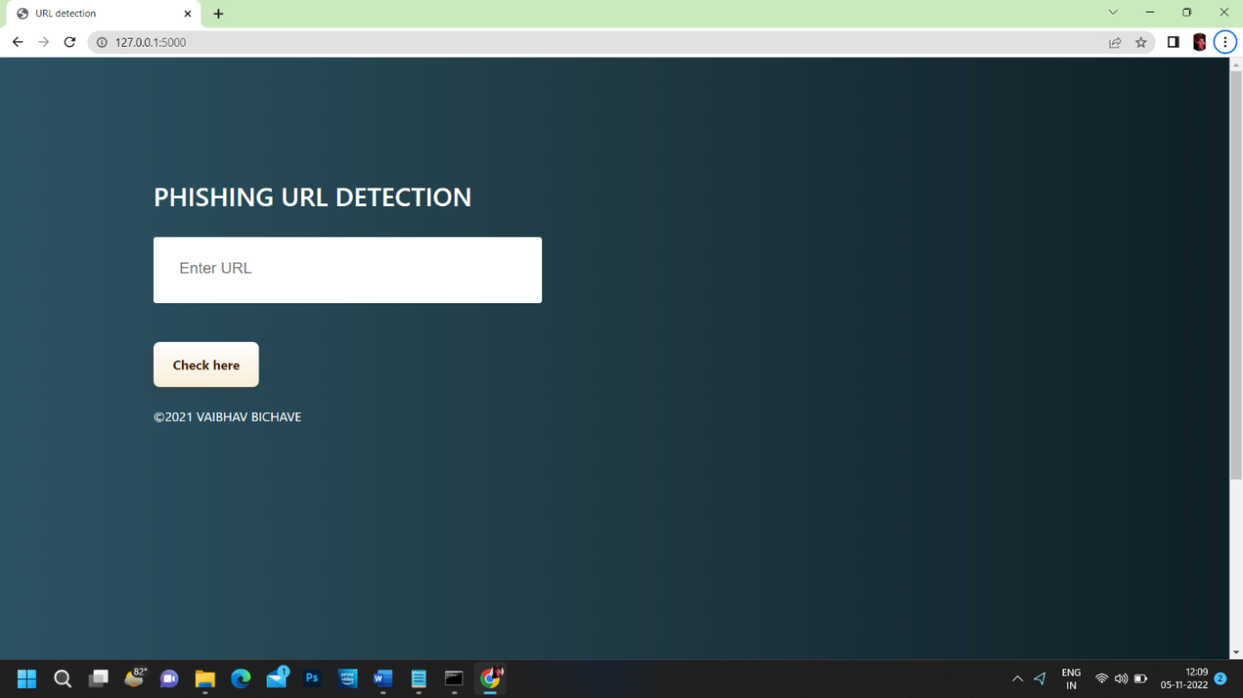

Screenshot 5.4: Interface of PHISHING URL DETECTION

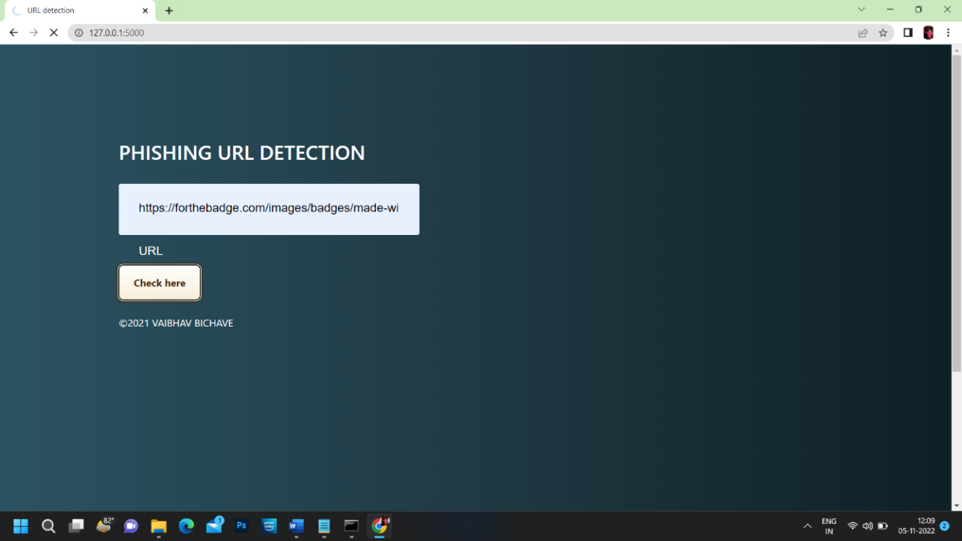

Screenshot 5.5: Checking the unknow URL site

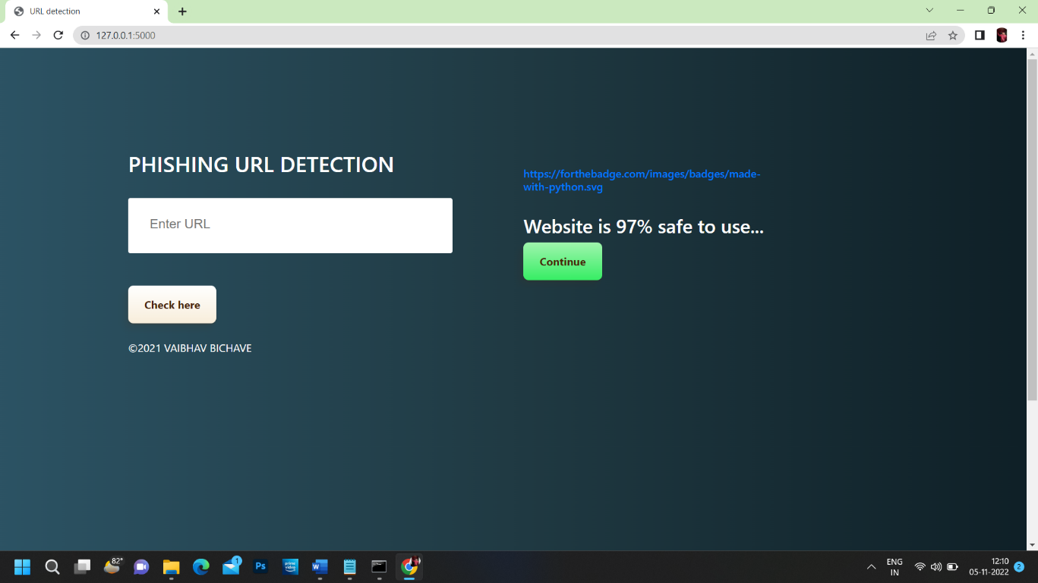

Screenshot 5.6: Result of the unknown URL site

## 6.TESTING

#### TESTING

##### INTRODUCTION TO TESTING

The purpose of testing is to discover errors. Testing is the process of trying to discover every conceivable fault or weakness in a work product. It provides a way to check the functionality of components, subassemblies, assemblies and/or a finished product. It is the process of exercising software with the intent of ensuring that the Software system meets its requirements and user expectations and does not fail in an unacceptable manner. There are various types of tests. Each test type addresses a specific testing requirement.

##### TYPES OF TESTING

* + 1. UNIT TESTING

Unit testing involves the design of test cases that validate that the internal program logic is functioning properly, and that program inputs produce valid outputs. All decision branches and internal code flow should be validated. It is the testing of individual software units of the application. It is done after the completion of an individual unit before integration. This is a structural testing that relies on knowledge of its construction and is invasive. Unit tests perform basic tests at component level and test a specific business process, application and/or system configuration. Unit tests ensure that each unique path of a business process performs accurately to the documented specifications and contains clearly defined inputs and expected results.

* + 1. INTEGRATION TESTING

Integration tests are designed to test integrated software components to determine if they actually run as one program. Integration tests demonstrate that although the components were individually satisfactory, as shown by successfully unit testing, the combination of components is correct and consistent. Integration testing is specifically aimed at exposing the problems that arise from the combination of components.

* + 1. FUNCTIONAL TESTING

Functional tests provide systematic demonstrations that functions tested are available as specified by the business and technical requirements, system documentation, and user manuals.

Functional testing is centered on the following items:

Valid Input : identified classes of valid input must be accepted.

Invalid Input : identified classes of invalid input must be rejected.

Functions : identified functions must be exercised.

Output : identified classes of application outputs must be exercised.

Systems/Procedures: interfacing systems or procedures must be invoked. Organization and preparation of functional tests is focused on requirements, key functions, or special test cases.

##### TEST CASES

* + 1. CLASSIFICATION

|  |  |  |  |  |
| --- | --- | --- | --- | --- |
| Test case ID | Test case name | Purpose | Input | Output |
| 1 | Phishing Detection | To Detect Suspicio-us URL’s . | The user gives the input in the form of URL. | An output gives the safe usage percentage of that URL |
| 2 | Phishing Detection | To detect Spam Mails. | The user gives the input in the form of URL | An output gives the safe usage percentage of that URL |

**7.CONCLUSION**

##### 7.CONCLUSION & FUTURE SCOPE

##### PROJECT CONCLUSION

The system developed detects if a URL link is phishing or legitimate by using machine learning models and deep neural network algorithms. The feature extraction and the models used on the dataset helped to uniquely identify phishing URLs and also the performance accuracy of the models used. It is also surprisingly accurate at detecting the genuineness of a URL link.

##### FUTURE SCOPE

Phishing is a growing problem for internet users. There are a number of anti-phishing tools available to cope against this problem. Still there are limitation on accuracy because detection techniques are time consuming. Among several machine learning algorithm, Random forest gives the better result. This work become unique from other existing work by proposing a group of features that can be extracted automatically using our own software tool. In future we can make the system available in mobile devices.

### 8.BIBLIOGRAPHY

##### 8. BIBLIOGRAPHY

##### REFERENCES

1. Liu J, Ye Y (2001) Introduction to E-business operators: commercial center arrangements, security issues, and market interest. In: E-business specialists, commercial center arrangements, security issues, and market interest, London, UK
2. From Internet in YouTube channels and websites like W3School
3. From Internship in company named Coign.

##### GITHUB LINK

<https://github.com/PhishingDetection/Sampathkumar>